**Respect for Umpires**

**Parents, Managers and Coaches**

**Background**

Joeys is very proud of the development programme it has in place for its young umpires, without whom there could be no games each Saturday. To be courtside, umpires, some of which can be as young as 11 years old, must have learnt the rules and passed a theory exam. More often than not they will have also volunteered their time to practice their skills. It falls on us as parents, managers and coaches to support our umpires by offering them training, mentoring and most importantly with our courtside behaviour on match day.

**The challenge for our umpires**

The majority of our umpires are young teenagers who are trying to learn to run a game of netball in a supportive environment. Even their mentors can be as young as 14 years old. Both are giving their time with a view to enabling players to have a fair and competitive game.

We understand that netball is a competitive game and we like to see our teams perform well. Very occasionally coaches and spectators can get ‘carried away’ and regrettably have been known to vent their frustrations on the umpires. Of course the umpires don’t always get 100% of the rules correct and cannot always see everything that happens on the courts. Occasionally they do make mistakes and when they do, we know that they regret their bad calls more than the players and spectators.

**Positioning on the court**

To complete their jobs effectively as umpires, they should be given unimpeded access to the court’s sidelines. The diagram below shows the correct positions for umpires, coaches, managers and parents.

Scorers/Managers should stand together and adjacent to the Centre circle and should not interact with the umpires or express comments about the umpiring while the game is in progress.

Coaches are requested not to wander up and down the sideline and should only stand in either of the goal thirds on the furthest left of a sideline. They should not interact with the umpires or express comments about decisions within earshot of an umpire. Even when they do stand in the appropriate third they should stay as far back from the line as possible so that an umpire can proceed into this area if needed; umpires must be able to see right to the base line.

Spectators

All courtside spectators should be requested to keep a clear line for the umpires to run – so they can watch the game and run without fear of tripping over something or someone.

Spectators should never to stand in the baseline areas of any court and should not walk between the baselines when play is in progress in these areas. Parents should ask their children not to play in the baselines along the fence areas.  Finally, all spectators are required to avoid making comments about umpiring calls as it can be extremely intimidating and upsetting to the umpires.

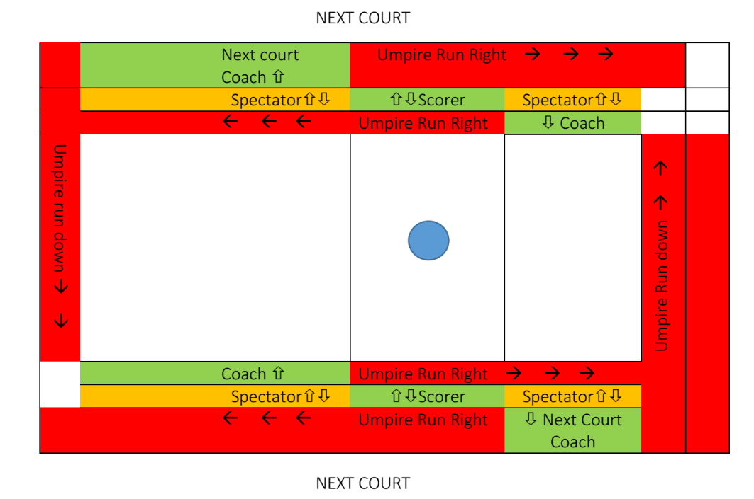

**Approaching Umpires**

Umpires should introduce themselves to each other at the beginning of the game and then stand together at each break.

The only people that are allowed to approach an umpire before, during or after a game are the Captains and the other umpire. (If the umpires are being mentored then the mentor will approach to offer coaching and advice.)

If a team has a concern about the application of a rule, or that another player is acting in a manner contrary to the spirit of the game, they should ensure the Captain approaches both umpires as soon as the break commences.

If a parent, or a coach or a manager approaches either umpire to discuss anything then they are breeching the code of conduct. That includes pre-warning of how a game might run, questioning a rule, commenting on missed calls etc. Finally, just like other sporting codes, no player, coach, manager or spectator should ever touch an umpire.

Let’s support our umpires to ensure that they can officiate to their very best ability, enjoy the experience and return to the game during subsequent seasons.

April 2016